Topic : Selenium
- What is Selenium?
Open source automation testing tool
Automate web based application
Supports multiple browser-chrome, edge, safari, firefox
Supports multiple platforms->windows, linux,
Supports language>java, C#, Python, PHP, Ruby, Javascript

- What are different components of Selenium?
Selenium RC-> depreciates
Selenium GRID-> multiple machine
WebDriver-> automates browser using code
Selenium IDE-> record and playback
Topic : Selenium WebDriver

- What is selenium WebDriver?
Selenium WebDriver is a an open source API which acts as a bridge between User action and browser.

- Explain architecture of selenium WebDriver?
Architecture consists of :
- Selenium Client library: Test Script , written using WebDriver API in java, python, etc.
- WebDriver API: Converts test script into protocol specific format . JSON protocol over HTTP (Selenium3)or W3C(Selenium=4) format
- Broser Driver: Accepts HTTP request from WebDriver, translate them into command which browser understand
ChromeDriver, EdgeDriver, GeckoDriver, OperaDriver, InternetExplore
- Browser-> execute the command, send response backs to driver
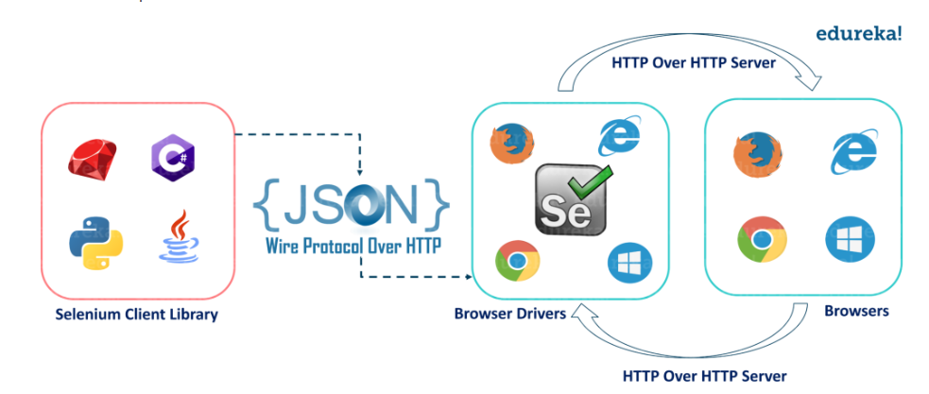
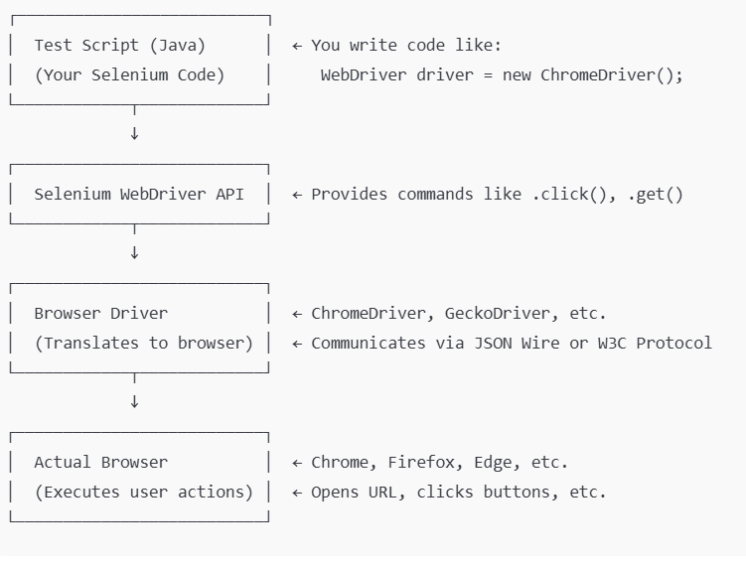
- What protocol are used by WebDriver?
- JSON Wire protocol: Selenium3
- W3C WebDriver protocol: Selenium4

- Is WebDriver a testing framework?
NO, it is automation tool

Topic : WebDriver Initialization

- How do you initialize WebDriver in selenium?
- WebDriver is an interface in selenium.
We initialize with specific WebDriver. Object instantiates of WebDriver. Create object of ChromeDriver class by referencing WebDriver interface.
WebDriver driver=new ChromeDriver();

B) WebDriverManager: automates the management of browser drivers like chromedriver.exe. It
- Detects browser version
- Downloads correct driver
- Sets up system property
✅No need to manually download and set driver path.

WebDriverManager.chromedriver().setup();
WebDriver driver = new ChromeDriver();

- Why do we write “WebDriver driver=new ChromeDriver” instead of “ChromeDriver driver=new ChromeDriver”?
WebDriver interface support cross browser support.

WebDriver driver = new ChromeDriver(); // ✅ Good practice
WebDriver driver = new ChromeDriver(); // ✅ Good practice

- How do we initialize WebDriver for multiple browsers (cross browser testing)?
WebDriver driver;
String browser=”chrome”;
If(browser.equalsIgnoreCase(“chrome))
{
WebDriverManager.chromedriver.setup();
driver=new ChromeDriver();
}else if(browser.equalsIgnoreCase(“edge”))
{
WebDriverManager.edgedriver.setup();
Driver=new EdgeDriver();
}else if(browser.equalsIgnoreCase(“Firefox))
{
WebDriverManager.firefoxdriver().setup();
Driver=new FireFoxDriver();
}
else
{
System.out.println(“browser not supported”)
}
- What are the ways to maximize browser window after initializing WebDriver?
driver.manage().window().maximize();
- What is the role of System.setProperty() in driver initialization?
Manually set the path to the browser driver executable?
System.setProperty(“webdriver.chrome.driver”,”path/choromedriver”);
WebDriver driver=new ChromeDriver();
➡️ Not required if you're using WebDriverManager.
- What if we don’t close or quite WebDriver properly?
Leaves Browser instances running in the background.
Memory consumption and system resources
Can cause test failure or timeouts in long runs
driver.quite(); //all browser open by selenium script are closed

driver.close(); // close current window

- What are OOPS concepts used in selenium WebDriver instantiation?
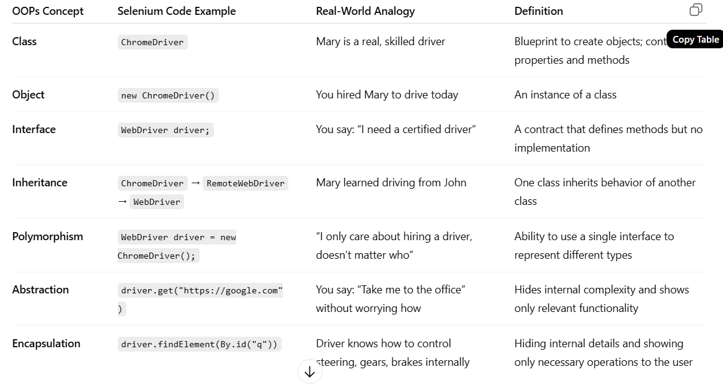
// Make sure to add Selenium WebDriver and ChromeDriver dependencies

import org.openqa.selenium.WebDriver;
import org.openqa.selenium.chrome.ChromeDriver;

public class SeleniumOOPExample {

public static void main(String[] args) {

// Set path to chromedriver executable if not using WebDriverManager
// System.setProperty("webdriver.chrome.driver", "path/to/chromedriver");

// 🔹 Polymorphism: WebDriver (interface) holds ChromeDriver (object)
WebDriver driver = new ChromeDriver(); // Object creation (class & object)

// 🔹 Abstraction: We use high-level methods to interact with browser
driver.get("https://www.google.com");

// 🔹 Encapsulation: Details of browser commands are hidden
String pageTitle = driver.getTitle();
System.out.println("Page Title is: " + pageTitle);

// 🔹 Close browser
driver.quit();
}}

Topic: Locators

- What are locators in selenium?
Locators are used to identify elements in web pages.

- What are different types of locators in selenium?
 | Locator  (find element in browser) | comment
driver.findElement(By.id("id")); | using the id attribute. | fastest  unique
driver.findElement(By.name("name")); | using the name attribute.
driver.findElement(By.className("class")); | using the class name. | fails if multiple class exists
driver.findElement(By.tagName("input")); | HTML tag name.
driver.findElement(By.linkText("Full Text")); | Finds link by exact visible text.
driver.findElement(By.partialLinkText("Partial")); | Finds link by partial visible text.
driver.findElement(By.cssSelector("input[name='q']")); | Uses CSS selectors to locate an element. | faster  no backward traversal
driver.findElement(By.xpath("//input[@id='username']")); | Uses XPath to locate an element by attributes. | slower  powerful for complex DOM structures

- What are different syntax of css selector?
 | Syntax
cssSelector | #id
 | .class
 | tag[attribute="value"]
 | div>input

- What are different function of xpath?
Function | XPath Syntax | Use / Meaning
text() | //a[text()='Login'] | Matches exact visible text
contains() | //div[contains(@class, 'menu')] | Matches partial text or attribute
starts-with() | //input[starts-with(@id, 'user')] | Starts with specific value
not() | //input[not(@type='hidden')] | Negates a condition
normalize-space() | //button[normalize-space()='Submit'] | Trims leading/trailing/multiple spaces
position() | (//input[@type='text'])[2] | Picks element at a specific position
last() | (//div[@class='item'])[last()] | Selects last element in a group
parent:: | //input/parent::div | Selects parent of an element
child:: | //div[@class='form']/child::input | Selects direct child
following:: | //label[text()='Email']/following::input | Next elements after current node
preceding:: | //input[@id='password']/preceding::label | Previous elements before node
ancestor:: | //input/ancestor::form | All ancestors of a node
descendant:: | //form/descendant::input | All nested children
following-sibling:: | //h2/following-sibling::p | Next sibling element(s)
self:: | //input[@id='email']/self::input | Refers to the same element

- Different function of css selector
Pattern | CSS Syntax | Use / Meaning
ID Selector | #username | Select element by ID (id="username")
Class Selector | .btn-primary | Select element by class (class="btn-primary")
Tag + Class | button.btn | <button class="btn">
Attribute | input[name='email'] | Match elements by attribute
Multiple Attributes | input[type='text'][name='email'] | Combine conditions
Starts With ^= | input[id^='user'] | Attribute starts with value
Ends With $= | input[name$='mail'] | Attribute ends with value
Contains *= | input[class*='form'] | Attribute contains value
Descendant | div form input | Any input inside a form inside a div
Direct Child | div > input | Direct child only
Adjacent Sibling | label + input | Next immediate sibling
General Sibling | label ~ input | All following siblings
nth-child | li:nth-child(3) | Select 3rd child of parent
nth-of-type | p:nth-of-type(2) | 2nd <p> element among siblings
not() | input:not([type='submit']) | Exclude elements with condition
Group Selectors | input, select, textarea | Select multiple types

- Difference between Relative xpath and Absolute xpath?
Type | Example | Notes
Absolute XPath | /html/body/div[1]/input | Starts from root, brittle
Relative XPath | //input[@id='email'] | Starts from anywhere, robust

- Which is better CSS or xpath?
✅ CSS is preferred when performance is key
->faster, simple, backward traversal not supported
✅ XPath is used for complex DOM traversal
->slower, powerful but verbose, backward traversal supported.

- What happen if multiple locators matched the selector?
driver.findElment(…)-> return the first matching elemet
driver.findElements(….)-> return the list of matching elements
- What does element.click() do in selenium?
Element.click()->
clicks on button, checkboc, radiobutton,link
if element is not visible or not interactable, click() throws ElementNotInteractableexception.
- A login button is not clickable. What are possible reasons?
There are several common reasons why any element) is not clickable in Selenium:
🔍 Check | ✅ Solution
❓ Is the element present in the DOM? | Use findElements().size() or ExpectedConditions.presenceOfElementLocated
❓ Is it visible (display != none) ? | Use element.isDisplayed()
❓ Is it enabled (not disabled)? | Use element.isEnabled()
❓ Is it covered by another element? | Use ElementClickInterceptedException or JS click
❓ Is it inside an iframe? | Use driver.switchTo().frame()
❓ Is it inside shadow DOM? | Use getShadowRoot() in Selenium 4
❓ Is the page still loading? | Use WebDriverWait for elementToBeClickable()

1. The element is disabled
- The button might be rendered on the page but is not enabled for interaction.
if (!element.isEnabled()) {
System.out.println("Button is disabled");
}
2. Element is covered by another element
- Sometimes a popup, loader, sticky header, or overlay might be blocking the button.
- Clicking will throw ElementClickInterceptedException.
✅ Use JavaScript workaround (only if safe):
((JavascriptExecutor) driver).executeScript("arguments[0].click();", element);
3. Page is still loading / element not ready
- The DOM may not be fully loaded or the element may appear with a delay.
WebDriverWait wait = new WebDriverWait(driver, Duration.ofSeconds(10));
wait.until(ExpectedConditions.elementToBeClickable(By.id("loginBtn"))).click();
4. Element is inside an iframe
- If the button is inside an <iframe>, Selenium can't access it directly.
✅ Switch to the iframe first:
driver.switchTo().frame("iframeName");
driver.findElement(By.id("loginBtn")).click();
5. Element is inside a shadow DOM
- Selenium (pre v4) can’t access elements in shadow DOM directly.
✅ In Selenium 4+:
SearchContext shadowRoot = driver.findElement(By.cssSelector("custom-element")).getShadowRoot();
WebElement btn = shadowRoot.findElement(By.cssSelector("button"));
btn.click();
6. Element is not visible (display: none or opacity: 0)
- Selenium won’t interact with elements hidden via CSS.
if (!element.isDisplayed()) {
System.out.println("Element is hidden");
}
7. Wrong locator
- The locator may match multiple elements or the wrong one entirely.
✅ Double-check with tools like Chrome DevTools, use more specific XPath/CSS.

🧠 Interview Tip:
"I would first check for visibility and enablement of the button, inspect DOM for overlays/iframes, and use explicit wait to ensure timing issues aren't causing the click failure."
public void clickLoginButton(WebDriver driver, By locator) {
try {
WebDriverWait wait = new WebDriverWait(driver, Duration.ofSeconds(10));

// Step 1: Check presence
List<WebElement> elements = driver.findElements(locator);
if (elements.isEmpty()) {
System.out.println("Element not present in DOM.");
return;
}

WebElement element = elements.get(0);

// Step 2: Check visibility
if (!element.isDisplayed()) {
System.out.println("Element is not visible on the page.");
return;
}

// Step 3: Check enablement
if (!element.isEnabled()) {
System.out.println("Element is disabled.");
return;
}

// Step 4: Wait until clickable
wait.until(ExpectedConditions.elementToBeClickable(locator));

// Step 5: Try clicking
try {
element.click();
System.out.println("Clicked successfully.");
} catch (ElementClickInterceptedException e) {
System.out.println("Element is not clickable, possibly covered. Trying JS click...");
JavascriptExecutor js = (JavascriptExecutor) driver;
js.executeScript("arguments[0].click();", element);
}

} catch (NoSuchFrameException e) {
System.out.println("Element might be inside an iframe. Switch to correct frame first.");
} catch (Exception e) {
System.out.println("Unexpected error: " + e.getMessage());
}
}

